Science Tutoring
Provided by Science National Honors Society

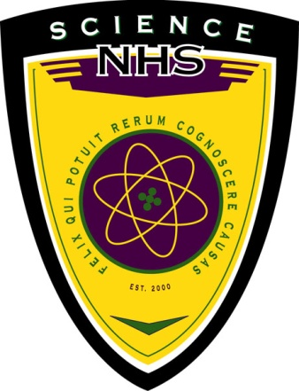

MONDAYS after school 2-3 PM ROOM 624
WEDNESDAYS during 4th Lunch ROOM 525
WEDNESDAYS during 5th Lunch ROOM 629
WEDNESDAYS during 6th Lunch ROOM 625
Fridays before school ROOM 525

